GIT HUB Repository

Git Bash for Windows is a package that includes git and bash.

Git is an open-source version control system for tracking source code changes when developing software. It keeps a commit history which allows you to revert to a stable state in case you mess up your code. Git also allows multiple developers to collaborate on the same code base.

Bash is a Unix command-line shell. The name is an acronym for the ‘Bourne-Again Shell’. It comes with useful Unix commands like cat, ssh, SCP, etc., which are not usually found on Windows.

Download the latest version of Git Bash from their official website: https://git-scm.com/

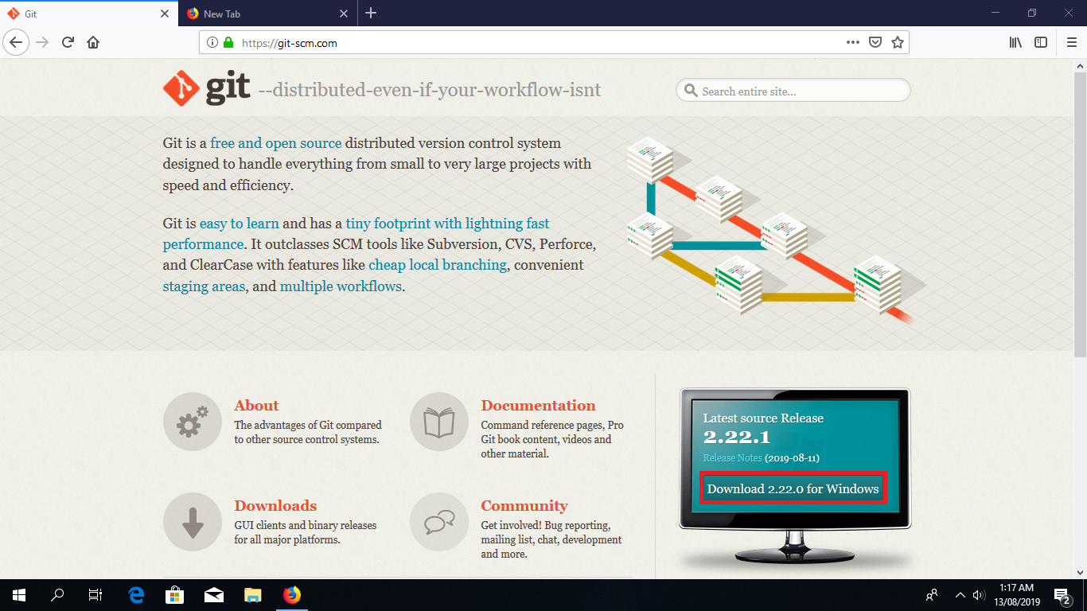

Click the “Download for windows” button.

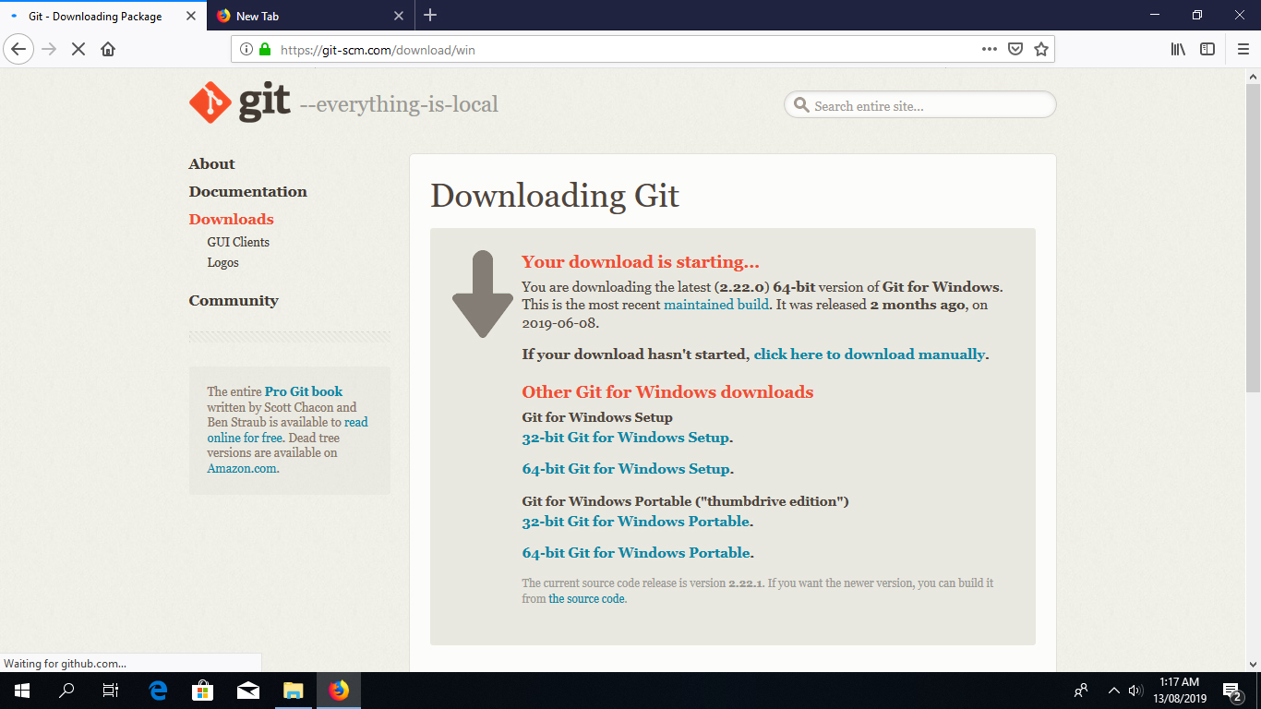

Once you have downloaded the Git Bash executable, click it to run the installer.

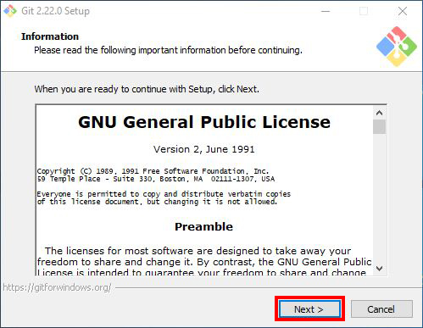

Click “Next” after you have read the license.

Next, select the location you want to install Git Bash. I would recommend you just leave the default option as it is, and click “Next”.

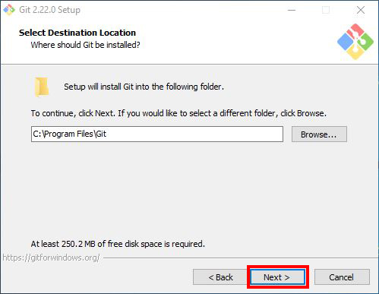

Choose the components you want to install, or you can just proceed with the default options and click “Next”. I prefer selecting the “Additional icons” component which creates a Git Bash shortcut on the desktop.

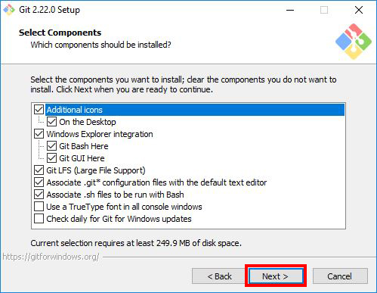

You can change the name of start menu folder here if you want, or just leave the default name and click “Next”.

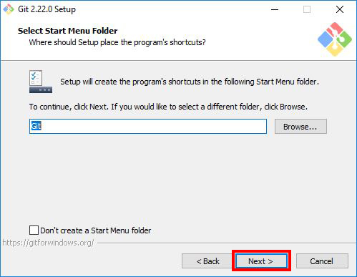

Next, select the default editor for Git to use. Choose the one you like and click “Next”. I would recommend you proceed with **Nano** or **Notepad++**. Don’t proceed with the default option “Vim” as it has a steep learning curve.

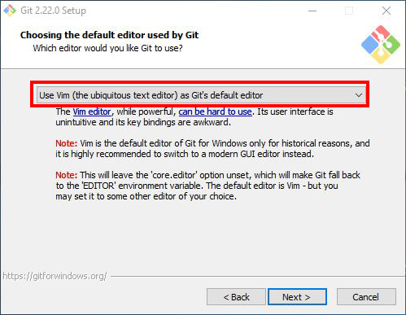

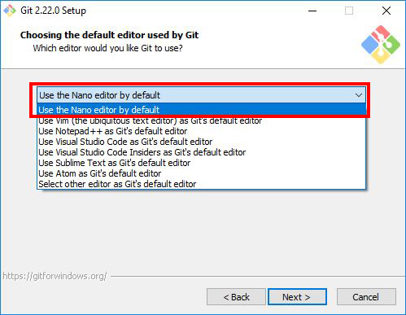 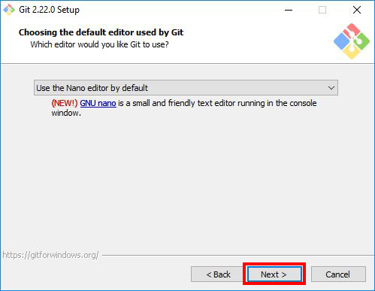

Choose the option you want depending on where you want to use Git and click “Next”.

Select “Use Git from Git Bash only” option if want to run Git and Bash commands from Git Bash only. This means that you won’t be able to run Git commands such as git status on Windows Command Prompt or Powershell. They will only be found on Git Bash.

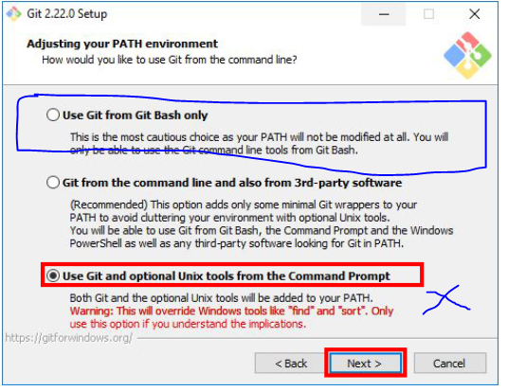

Next, select “Use the OpenSSL library” and click “Next”.

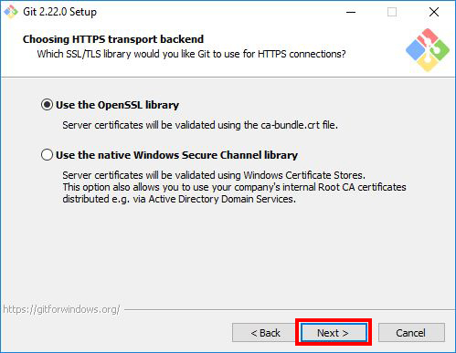

Select how Git should treat line endings in text files. It’s probably safe to go with the default option “Checkout Windows-Style, commit Unix-style line endings”. Click “Next” to proceed.

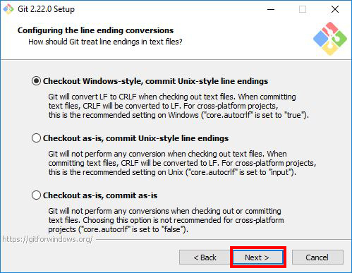

Next, select the terminal emulator you want Git Bash to use. I will proceed with the default option “Use MinTTY(the default terminal of MSYS2) and click “Next”.

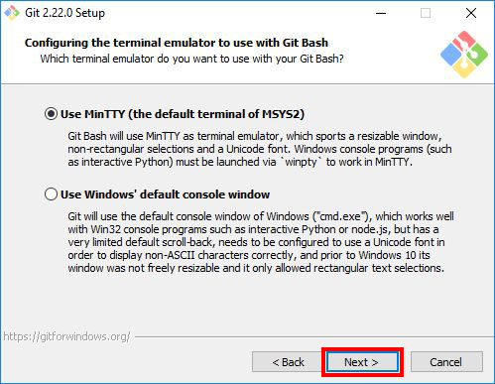

Select the features you want(the default options are fine) and click “Next”.

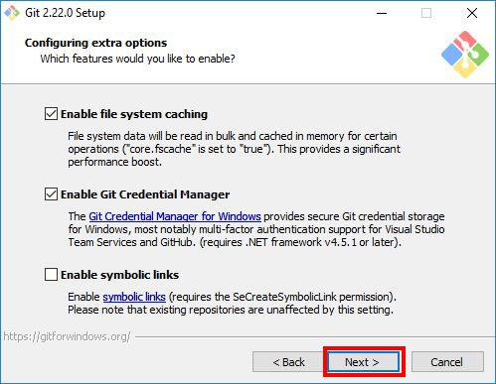

Enable experimental options if you want. Enabling them allows you to try out newer features that are still in development. I don’t enable this, so I will just proceed by clicking “Install” to start the installation process.

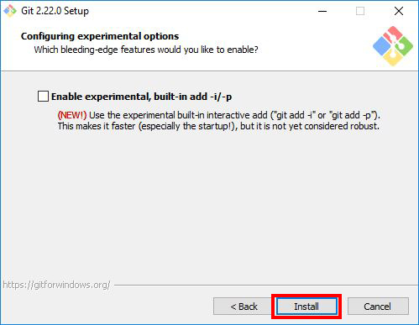

Now, wait for a few minutes as the Setup Wizard installs Git on your computer.

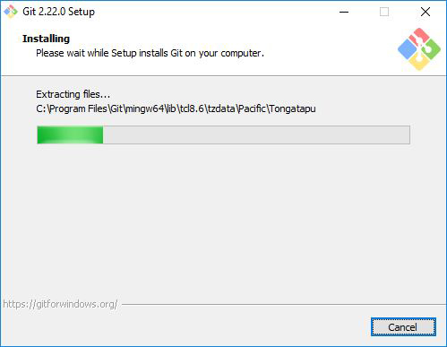

After the installation has finished, check the “Launch Git Bash” and click “Finish” to launch Git Bash.

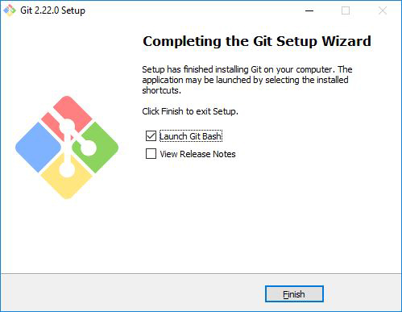

The Git Bash terminal will now open and you will be able to enter Git and Bash commands.

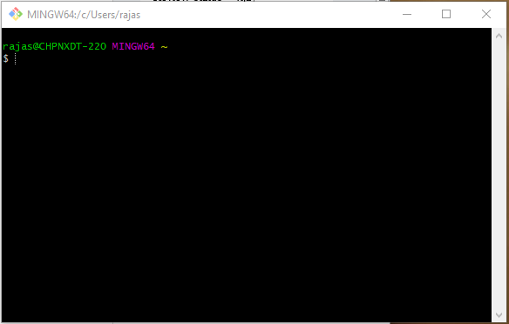

**Launching Git Bash**

The following are just some tips on how you can easily launch Git Bash.

Right-click on any folder, anywhere and it will have the launch Git Bash option on the context menu.  
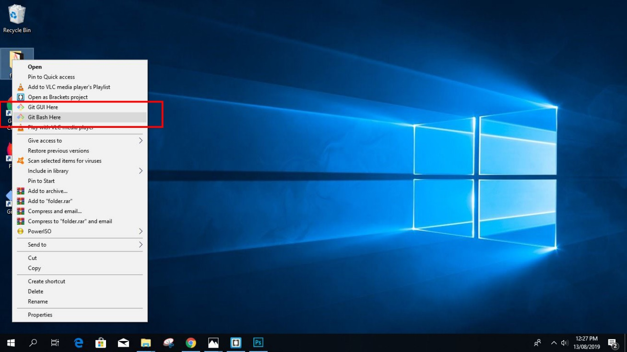

**2.** If you enabled the “Additional icons” option on **Step 5**, you can easily launch Git Bash by clicking the Git Bash desktop icon.

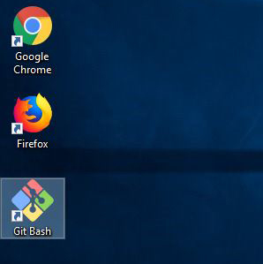

**3.** If you chose the **third option** “Use Git and optional Unix tools from the Command Prompt” on **Step 8**. You can run both Git and Bash commands by opening Windows Command Prompt or Powershell.

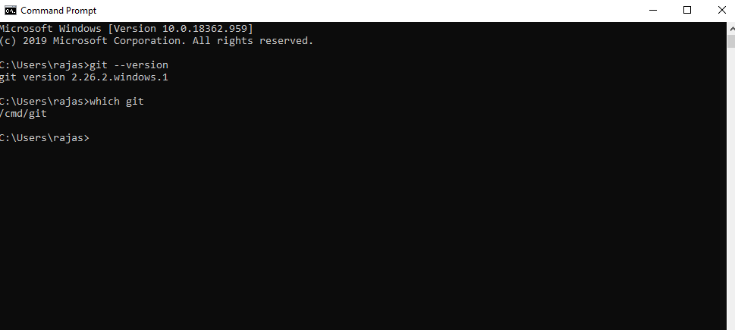

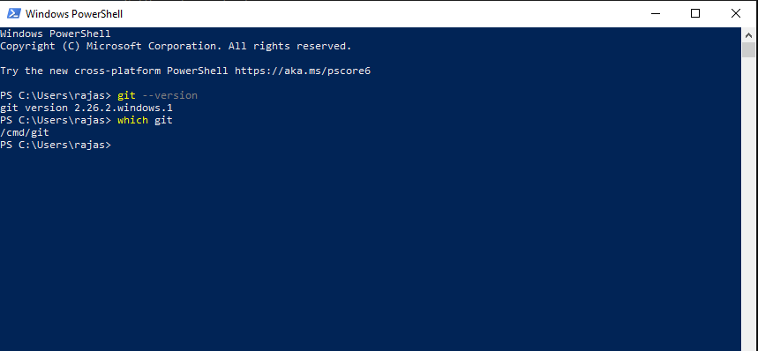

**More Details**

Use this Link : <https://www.stanleyulili.com/git/how-to-install-git-bash-on-windows/>

How to install GitHub Desktop

**Installation**

The installation of GitHub Desktop is as simple as any other Windows application installation. All you need to do is:

1. Open a browser.
2. Visit desktop.github.com.
3. Click Download for WIndows (64bit).
4. When prompted, click Run.
5. Allow the installation to download and install.

Once the installation completes, GitHub Desktop will launch.

The next step is to sign in with your GitHub credentials. If you don't already have a GitHub login, head over to the signup page and create a new (free) account. Once you successfully sign in, you are ready to start using GitHub Desktop

[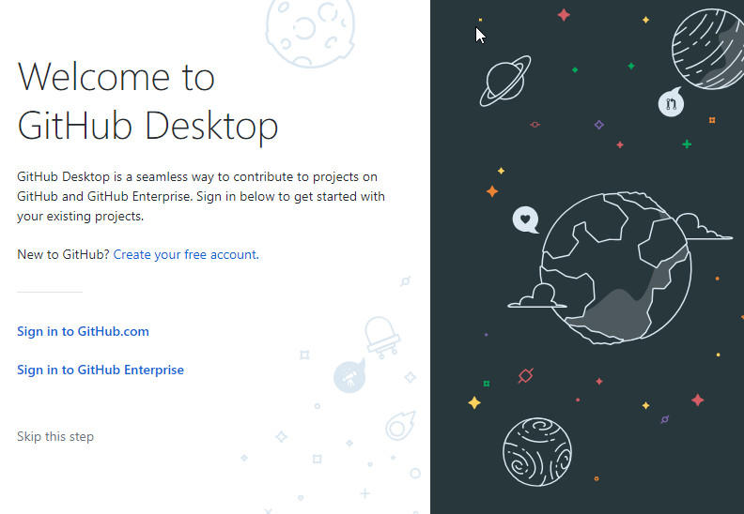](https://tr2.cbsistatic.com/hub/i/2019/06/19/01cbe633-b43a-429c-b966-338ded614577/githuba.jpg)

With GitHub Desktop open, you can drag and drop repositories from within the file manager to automatically add them to your Git repository, or you can clone a repository from your GitHub account to your local drive (repositories clone to C:\Users\NAME\Documents\GitHub--where NAME is your Windows username). With a repository cloned to your local drive, you can start working on it locally and then compare, merge, rebase, and more. Once your work is complete, you can push it back to GitHub by clicking Repository | Push. If you work with a team, you can create new pull requests by clicking Repository | Pull.

If you attempt to open your project in a command prompt, you might find that Git hasn't been installed. That's right, even though GitHub Desktop does depend on Git, it doesn't install that dependency. Fortunately, you can install Git from within GitHub Desktop. To do this, click Repository | Open in Command Prompt, and you will be prompted to install Git

[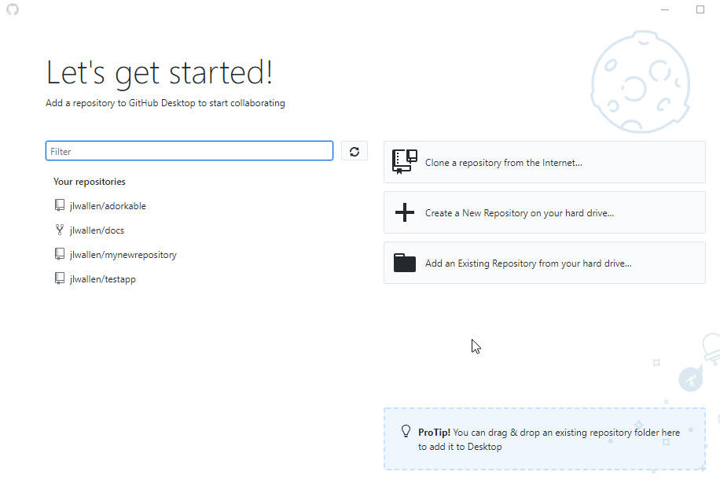](https://tr1.cbsistatic.com/hub/i/2019/06/19/b626602c-c9c8-4553-b802-0a88fb425e87/githubb.jpg)

You can now use the interface of GitHub Desktop to do your git operations.

